# American Airlines Route Optimization

**BUAN 6390**

**TEAM 5**

Charan Sai Alaparthi

Jeevana Priya Chalichalamala

Barath Kumar Dhanasekar

Jennifer Rose Koenig

Venkata Akhil Reddy Padigepati

Anusha Sathravada

Vamsikumar Sripathyreddy

Nitisha Sree Venkatesan

### **Why American?**

American Airlines and the impact of COVID-19 was suggested as a starting point for our project on the first day of class. That seed stayed planted in our minds as we brainstormed project ideas in the following weeks. American Airlines is one of the three largest airlines in the world. They also happen to be headquartered in Fort-Worth, Texas, which also added a local flair to our project. While we were exploring datasets and performing initial market research, we learned that American was not performing as well as their top two competitors. Despite their ranking as the largest carrier by passenger kilometres flown, we found they are facing challenges financially. American has not rebounded after the pandemic as quickly as competitors, and lags behind both Delta and United in profit margins.

Recently American has been in the news for several critical business events, which further piqued interest in the organization further. In 2024 alone, American made the news for restricting their mileage program, ending a years-long negotiation with flight attendants, and losing an appeal to preserve their Northeast Alliance with JetBlue. Socially, American’s reputation has suffered as well. In the last six months, the airline was publicly held to account for both racial discrimination and disability rights violations.

Some of American’s struggles can be traced back to the 2013 merger with US Airways. While research shows the two airlines were successful in achieving efficiency post-transaction, there were other market level impacts of the union. There were cost disparities in fares between the two carriers, which require an upward scaling in prices. American also lost out routes based out of Los Angeles and Chicago due to pricing competition from Delta and United. Their strategy was to “double-down” on their sunbelt strongholds in DFW, Charlotte, Miami, and Washington-Reagan, but the pandemic quashed hopes of regional growth.

### **Our Goal**

The goal of our project is to provide American Airlines with actionable recommendations on how to improve their profit margin. We explore improvements to existing routes, potential new routes and fare design.

### **Strategy**

Our main strategy was to optimize both direct and connecting flights to make them more profitable and customer friendly. Since American Airlines has a strong presence in the Sunbelt region, we focused on using Sunbelt hubs (like DFW in Dallas, PHX in Phoenix, CLT in Charlotte, and MIA in Miami) to increase accessibility and connectivity across different parts of the U.S. This setup allows the airline to better serve passengers

in the Sunbelt area while efficiently connecting them to other regions through these major hubs.

To make the flights more appealing, we created a dynamic pricing model that adjusts fares based on booking windows, peak travel seasons, and the type of flight (direct or connecting). By capping fares at reasonable levels, we also ensured that passengers get a good deal, which can boost customer satisfaction and encourage more bookings.

### **Tools**

* **Geopy Library**: We used the geopy library to calculate real-world distances between cities and airports. This gave us accurate travel times and fuel costs based on actual geography, which is crucial for realistic pricing and cost estimations.
* **Python**: Python was the primary programming language used for the code, as it allowed us to easily implement distance calculations, dynamic pricing logic, and profit calculations.

### **Methods**

* **Dynamic Pricing Model**: We created a pricing structure that adjusts fares based on how close the booking date is to the travel date and whether it is a peak season (like Thanksgiving or Christmas). This approach helps maximize revenue during high-demand periods.
* **Geographic Validation for Layovers**: To prevent redundant or impractical layovers, we used a geographic distance check to ensure that layover cities are sufficiently far from both the start and end cities. This ensures that connecting flights are more efficient and meaningful.
* **Cost and Profit Calculations**: For each flight, we calculated the operating costs (fuel and airport charges) and then compared this with the revenue to ensure every route remains profitable.

### **What We Did Not Use**

* **Real-Time Data Feeds**: We did not integrate any live data sources for fuel prices or airport fees. This could be a valuable addition in the future to make cost estimations even more accurate.
* **Machine Learning for Demand Forecasting**: Although a machine learning model could help predict demand on different routes, we kept the project focused on foundational elements like distance, pricing, and profit calculations. Demand forecasting could be a future enhancement to further fine-tune pricing.
* **Complex Route Optimization Software**: While some airlines use advanced software for route optimization, our project focused on simpler, realistic routing that ensured profitability and accessibility across the Sunbelt region.

### **Challenges**

* **Avoiding Redundant Layovers**: One of the first challenges we encountered was ensuring that layover cities were not too close to the start or end cities. For example, a route from Dallas to Miami with a layover in Dallas/Fort Worth did not make sense. To solve this, we implemented a minimum distance requirement for layovers to make sure they were genuinely useful for connecting flights.
* **Creating a** **Fair, Yet Profitable Pricing Model**: Balancing customer-friendly prices with airline profitability was a key challenge. We wanted to ensure that passengers were not overcharged, especially on connecting flights, while still making sure each route covered its operating costs. The solution was to cap fares and use dynamic adjustments based on booking windows and travel seasons to keep prices competitive.
* **Accurate Cost Estimations**: Getting realistic estimates for fuel and airport charges was important to ensure that our profit calculations were reliable. Setting these costs too high would make flights seem unprofitable, while setting them too low would not reflect real-world conditions. By using conservative estimates and basing calculations on distance, we struck a balance between accuracy and feasibility.
* **Ensuring Connectivity Across Regions**: Since American Airlines focuses on the Sunbelt region, we had to ensure that routes effectively connected passengers across this area while also providing access to other regions. Using Sunbelt hubs as strategic layovers helped us maintain American Airlines’ strong presence in this region while extending connectivity to other parts of the U.S.

### **Key Findings**

### **COVID IMPACT**

**Airlines with Positive Market Share Growth**

* **American Airlines (AA): +0.85%**
  + A modest gain in market share suggests effective strategies like maintaining critical routes or improving customer experience post-COVID.
* **Alaska Airlines (AS): +1.85%**
  + A significant increase may reflect its strong presence in regional markets and an ability to capitalize on recovering travel demand.
* **Delta Airlines (DL): +1.12%**
  + Delta's strategic moves, such as expanding operations or offering competitive pricing, likely contributed to its growth.
* **Frontier Airlines (F9): +0.29%**
  + This low-cost carrier may have slightly improved its market share by attracting budget-conscious travelers.
* **United Airlines (UA): +1.69%**
  + A notable increase suggests United adapted well to post-COVID dynamics, perhaps by optimizing long-haul routes or tapping into business travel recovery.

**2. Airlines with Negative Market Share Growth**

* **JetBlue Airways (B6): -0.71%**
  + The decline could be due to increased competition on overlapping routes or operational challenges during the recovery period.
* **Allegiant Air (G4): -0.34%**
  + Focused primarily on leisure travel, Allegiant may have faced competition from larger carriers or reduced demand in specific markets.
* **Sun Country Airlines (SY): -0.04%**
  + A minimal decline suggests that Sun Country mostly retained its market presence but faced slight pressure from other carriers.
* **Southwest Airlines (WN): -5%**
  + The largest decline among carriers. Southwest's reliance on a point-to-point model might have been less resilient to pandemic-induced shifts, or it could indicate passenger preference for other carriers post-COVID.
* **Spirit Airlines (NK): -0.91%**
  + Spirit’s decrease might result from intensified competition in the ultra-low-cost segment or reduced passenger interest in its service model.

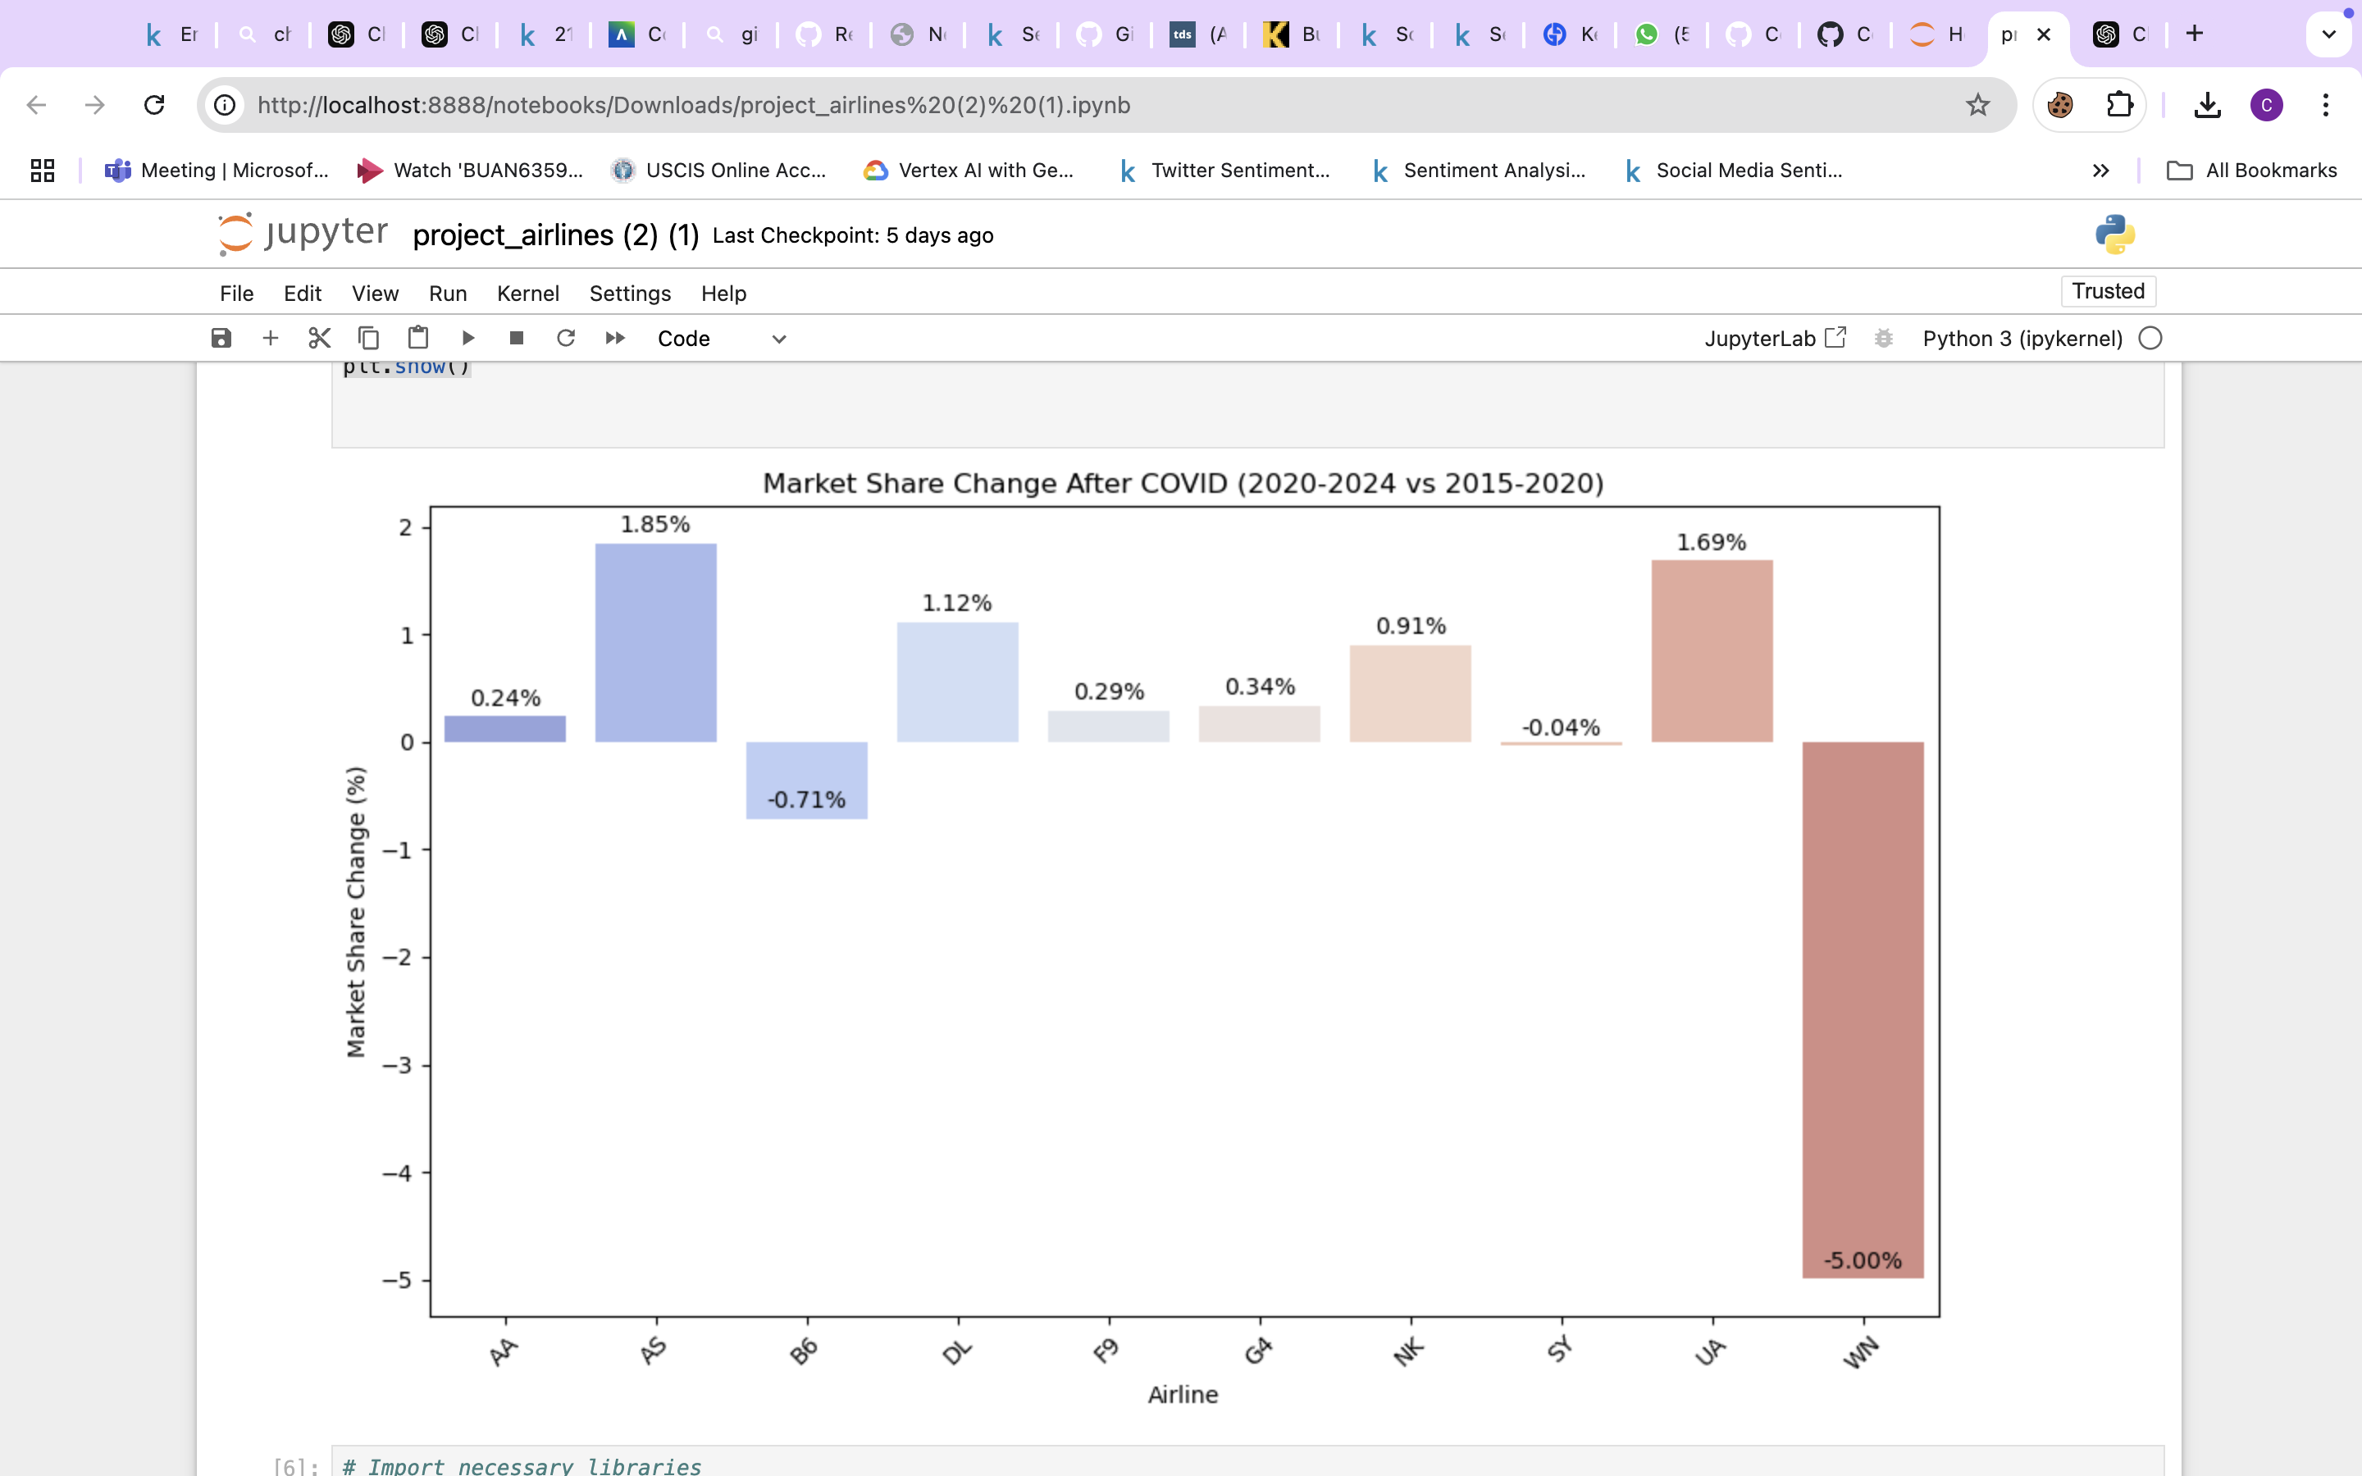

**Key Insights**

1. **Major Winners**:
   1. Alaska Airlines (+1.85%) and United Airlines (+1.69%) show strong recovery and growth post-COVID, indicating potential market leadership in certain regions.
2. **Significant Losers**:
   1. Southwest Airlines (-5%) and Spirit Airlines (-0.91%) experienced the largest declines, potentially reflecting operational challenges or shifting consumer preferences.
3. **Overall Trends**:
   1. Legacy carriers (e.g., AA, DL, UA) generally fared well, potentially benefiting from business travel and long-haul route recovery.
   2. Low-cost carriers had mixed results, with some (e.g., Frontier) gaining slightly and others (e.g., Spirit) losing market share.

**Strategic Implications**

* **For Airlines Gaining Share**: Continue leveraging competitive strengths such as network coverage, pricing strategies, and customer service improvements.
* **For Airlines Losing Share**: Reevaluate route strategies, focus on differentiating service offerings, and address key operational challenges to regain market share.

***Passengers vs. Market Share (large_ms)*:**

* A scatter plot visualizes how the number of passengers relates to the market share of large carriers (*large_ms*).
* Observations:
  + The spread or trend of the points helps identify correlations or patterns (e.g., linearity, clustering).
  + A weak or scattered relationship suggests low correlation.

***Fare vs. Market Share (large_ms)*:**

* Similarly, this plot examines how fare levels impact the market share of large carriers.
* Observations:
  + A negative slope or scattered points might indicate that higher fares are associated with lower market share.

**Correlation Matrix**

* The correlation table provides pairwise correlation coefficients (ranging from -1 to +1) between variables:
  + **Passengers and Fare**: Moderate negative correlation (-0.21), suggesting that routes with more passengers may have lower fares.
  + **Passengers and large_ms**: Very weak negative correlation (-0.018), indicating almost no linear relationship.
  + **Fare and large_ms**: Weak negative correlation (-0.234), suggesting that higher fares might slightly reduce the market share of large carriers.
  + **large_ms and lf_ms**: Moderate positive correlation (0.528), showing some overlap between these market share measures.

**Regression Analysis**

***Model 1: Predicting large_ms using Passengers and Fare*:**

* **Dependent variable (Y)**: large_ms (market share of large carriers).
* **Independent variables (X)**: passengers and fare.

Key Regression Outputs:

* **R-squared**: 0.060 (6% of the variance in large_ms is explained by the model).
* **Coefficients**:
  + Constant: 0.8510 (baseline market share when passengers and fare are 0).
  + Passengers: -4.548e-05 (a very small negative effect, meaning increasing passengers slightly reduces market share).
  + Fare: -0.0008 (negative impact, higher fares reduce market share).
* **Significance**: Both predictors have very low p-values (<0.05), indicating they are statistically significant, despite the small effect sizes.

***Model 2: Predicting lf_ms using Passengers and Fare*:**

* **Dependent variable (Y)**: lf_ms (market share of low-cost carriers).
* **Independent variables (X)**: passengers and fare.

Key Regression Outputs:

* **R-squared**: 0.091 (9% of the variance in lf_ms is explained by the model).
* **Coefficients**:
  + Constant: 0.7882 (baseline market share for low-cost carriers when passengers and fare are 0).
  + Passengers: -0.0002 (negative effect, more passengers slightly reduce market share for low-cost carriers).
  + Fare: -0.0014 (stronger negative impact compared to large_ms).
* **Significance**: Both predictors are statistically significant (p-value < 0.05)**Key Insights**

1. **Passengers**:
   1. Both models show a negative relationship with market share, but the effect size is very small, suggesting minimal practical impact.
2. **Fare**:
   1. Fare has a stronger negative effect on market share for low-cost carriers (lf_ms) than for large carriers (large_ms).
   2. Indicates that higher fares disproportionately affect low-cost carrier competitiveness.
3. **Model Fit**:
   1. Both models have low R-squared values (6% and 9%), indicating that other factors likely explain market share variability.

### **Market Dynamics**

The analysis reveals significant shifts in air travel demand, particularly in cities beyond the traditional Sunbelt region. Cities like Denver, Chicago, and Seattle are experiencing substantial growth due to major investments in transportation infrastructure. Air traffic growth in these regions is projected to exceed 80%, creating opportunities for American Airlines to establish new hubs and diversify operations. These emerging hubs offer the potential to reduce dependency on traditional Sunbelt hubs and improve connectivity to underserved regions. Additionally, route optimization strategies can reduce travel times and enhance connectivity for both business and leisure travellers.

### **Route Analysis**

The analysis of direct and connecting flights highlights the importance of dynamic pricing models that adjust fares based on seasonal demand fluctuations, booking windows, and distance-based pricing. For direct flights, fuel expenses are set at $3.00 per gallon, with airport charges calculated at a base rate of $2500 plus $0.1 per mile flown. The average flight speed of 500 mph ensures consistent scheduling and operational planning.

For connecting flights, the focus is on leveraging Sunbelt hubs such as Dallas/Fort Worth (DFW), Charlotte (CLT), Phoenix (PHX), and Miami (MIA). These hubs allow for optimized layover durations (2–5 hours), ensuring cost-effective operations while providing convenient transfers for passengers. Additionally, base fares for connecting flights are strategically lower than those for direct flights to attract price-sensitive travellers. This approach expands geographical coverage and enhances service options to smaller or secondary markets.

### **Financial Implications**

### **Revenue Optimization**

The dynamic fare structure is designed to maximize revenue while maintaining competitiveness. Economy fares are capped at $350 for direct flights and $300 for connecting flights, ensuring affordability for passengers while promoting volume growth. First-class fares are set at 1.75x the economy fare, with a cap of $600 to balance exclusivity with accessibility.

### **Cost Management**

Fuel costs are managed through a burn rate of 3.5 gallons per mile, providing predictable fuel expenses per route. Dynamic airport charges are adjusted based on route distance, ensuring that operational costs remain aligned with profitability goals. By optimizing passenger capacity (150 seats per aircraft), American Airlines can improve revenue per flight while minimizing per-passenger costs.

### **Strategic Recommendations**

### **1. Network Expansion**

American Airlines should invest in emerging hubs like Denver, Chicago, and Seattle to tap into growing passenger traffic and leverage infrastructure improvements in these cities. Introducing new routes that connect high demand, but underserved markets will help align operations with shifting travel patterns. Enhancing the hub-and-spoke model from their current hubs will also maximize network efficiency by connecting secondary markets to major hubs.

### **2. Operational Efficiency**

To improve operational efficiency, American Airlines should optimize flight routes to minimize travel times while maintaining service quality. Implementing a comprehensive layover strategy that balances cost-effectiveness with passenger convenience will enhance the appeal of connecting flights. Furthermore, focusing on aircraft utilization by improving scheduling will reduce idle time and increase flight frequency on high-demand routes.

### **3. Market Positioning**

American Airlines can alleviate congestion in traditional Sunbelt hubs by redistributing traffic to emerging hubs, reducing delays and operational bottlenecks. Leveraging new infrastructure investments in growing markets will help secure a competitive advantage and position American Airlines as the preferred carrier in these regions. Additionally, utilizing dynamic pricing models tailored to regional price sensitivity will enhance customer satisfaction while maximizing revenue potential.

### **Future Outlook**

The aviation industry is undergoing significant changes driven by infrastructure development, shifting travel patterns, and evolving customer expectations. American Airlines is well-positioned to capitalize on these trends by adopting a forward-thinking strategy focused on expanding into emerging markets and investing in non-traditional hubs to diversify its network.

By optimizing route networks to balance demand with operational efficiency and exploring opportunities for nonstop long-haul routes, American Airlines can further strengthen its market presence. Implementing dynamic pricing models tailored to seasonal demand fluctuations will ensure that revenue is maximized without sacrificing competitiveness. Accounting for customer sentiment in this modelling will be critical.

Finally, by leveraging effective cost management practices such as fuel cost optimization and efficient resource allocation, American Airlines can enhance profitability while maintaining resilience in the face of industry challenges. This strategic alignment will ensure long-term growth and sustainability for the airline as it navigates an increasingly competitive global aviation market.

We suggest incorporating airline partnerships and the impact of international hubs for this model. American is the largest airline carrier globally and there may be strategic changes or partnerships that would improve domestic performance.

### **References**:

* <https://fortune.com/2023/11/11/tailspin-american-airlines-stock-debt-travel-outlook/>
* <https://www.sciencedirect.com/science/article/pii/S0969699722000473>
* <https://www.reuters.com/business/aerospace-defense/american-airlines-lifts-2024-profit-forecast-improved-pricing-2024-10-24/>
* <https://www.sciencedirect.com/science/article/pii/S1877050916304707>
* <https://www.statista.com/statistics/1400987/american-airlines-fuel-consumption-by-type/>
* <https://www.sciencedirect.com/science/article/abs/pii/S0198971523000364>